SUPPLEMENTARY MATERIALS

Supplementary Figures

Shoot Height (SH)
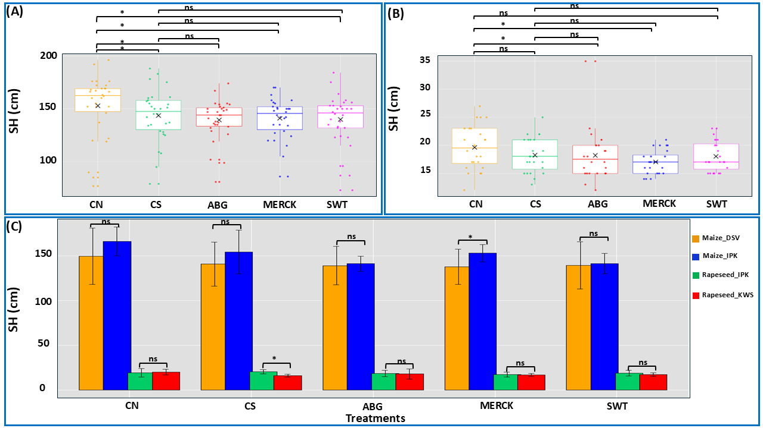
Figure S1. Shoot height analysis. Box plots display SH in maize (A), rapeseed (B), and cultivar comparisons across both plant species (C). Panels A and B depict treatment effects (treatments: SAPs and both control groups) (treatments: SAPs and both control groups) independent of cultivar differences, while panel C illustrates the influence of cultivar on treatment outcomes. Statistical analysis was performed using the Kruskal–Wallis test, followed by Dunn’s test for post hoc pairwise comparisons. The symbol ‘ns’ denotes no significant difference between comparison pairs, and ‘*’ indicates significant differences at α = 0.05. The ‘×’ symbol represents the mean value for each treatment. In panel C, the colors represent the following genotypes: orange color stands for the maize genotype provided by DSV company, blue color stands for the maize genotype from IPK, green color stands for rapeseed genotype provided by IPK, and red color stands for the rapeseed genotype from KWS company.

Root Length (RL)
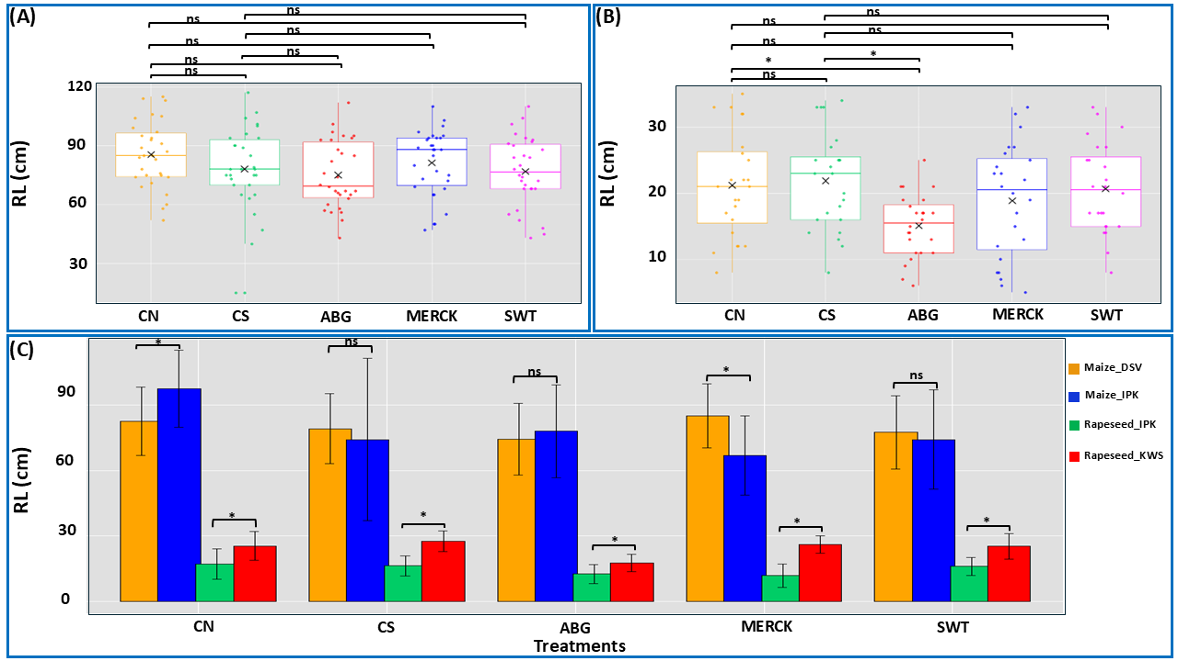
Figure S2. Root length analysis. Box plots display RL in maize (A), rapeseed (B), and cultivar comparisons across both plant species (C). Panels A and B depict treatment effects (treatments: SAPs and both control groups) (treatments: SAPs and both control groups) independent of cultivar differences, while panel C illustrates the influence of cultivar on treatment outcomes. For maize, statistical analysis was performed using one-way ANOVA, followed by Tukey’s test for post hoc pairwise comparisons. Statistical analysis for rapeseed was conducted using the Kruskal–Wallis test, followed by Dunn’s test for post hoc pairwise comparisons. For the cultivar comparison, one-way ANOVA was performed, with Tukey’s test applied for post hoc pairwise comparisons. The symbol ‘ns’ denotes no significant difference between comparison pairs, and ‘*’ indicates significant differences at α = 0.05. The ‘×’ symbol represents the mean value for each treatment. In panel C, the colors represent the following genotypes: orange color stands for the maize genotype provided by DSV company, blue color stands for the maize genotype from IPK, green color stands for rapeseed genotype provided by IPK, and red color stands for the rapeseed genotype from KWS company.

Leaf Area (LA)
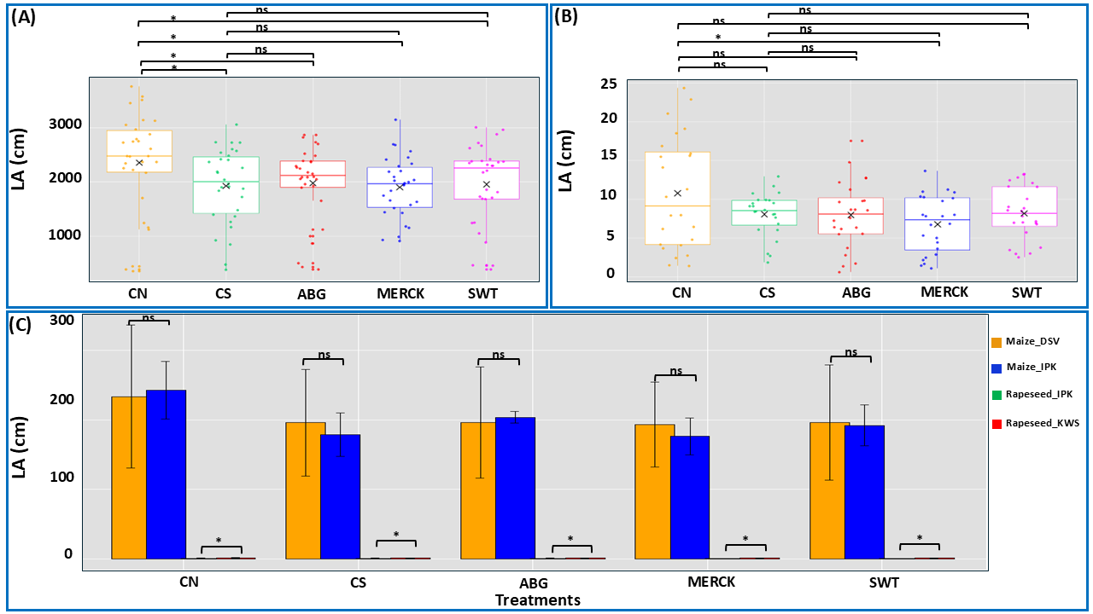
Figure S3. Leaf area analysis. Box plots depict LA in maize (A), rapeseed (B), and cultivar comparisons across both plant species (C). Panels A and B display treatment effects (treatments: SAPs and both control groups) independent of cultivar differences, while panel C illustrates the influence of cultivar on treatment outcomes. Statistical analysis was performed using the Kruskal–Wallis test, followed by Dunn’s test for post hoc pairwise comparisons. The symbol ‘ns’ denotes no significant difference between comparison pairs, and ‘*’ indicates significant differences at α = 0.05. The ‘×’ symbol represents the mean value for each treatment. In panel C, the colors represent the following genotypes: orange color stands for the maize genotype provided by DSV company, blue color stands for the maize genotype from IPK, green color stands for rapeseed genotype provided by IPK, and red color stands for the rapeseed genotype from KWS company.

Root Area (RA)
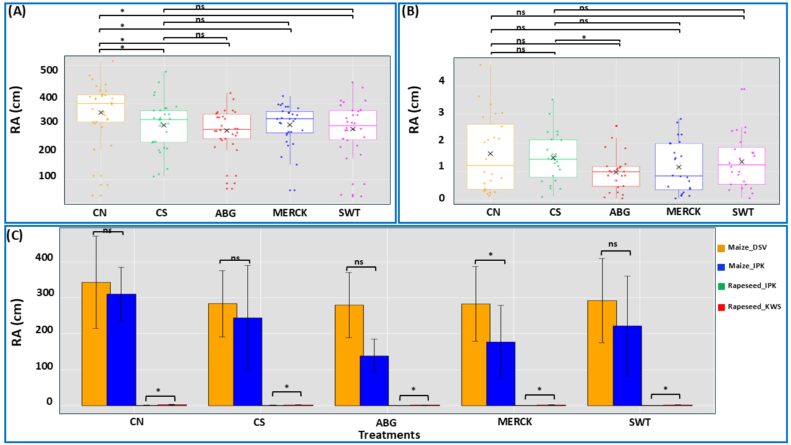
Figure S4. Root area analysis. Box plots depict RA in maize (A), rapeseed (B), and cultivar comparisons across both plant species (C). Panels A and B display treatment effects (treatments: SAPs and both control groups) independent of cultivar differences, while panel C illustrates the influence of cultivar on treatment outcomes. Statistical analysis was performed using the Kruskal–Wallis test, followed by Dunn’s test for post hoc pairwise comparisons. The symbol ‘ns’ denotes no significant difference between comparison pairs, and ‘*’ indicates significant differences at α = 0.05. The ‘×’ symbol represents the mean value for each treatment. In panel C, the colors represent the following genotypes: orange color stands for the maize genotype provided by DSV company, blue color stands for the maize genotype from IPK, green color stands for rapeseed genotype provided by IPK, and red color stands for the rapeseed genotype from KWS company.

Plant Dry Weight (PDW)
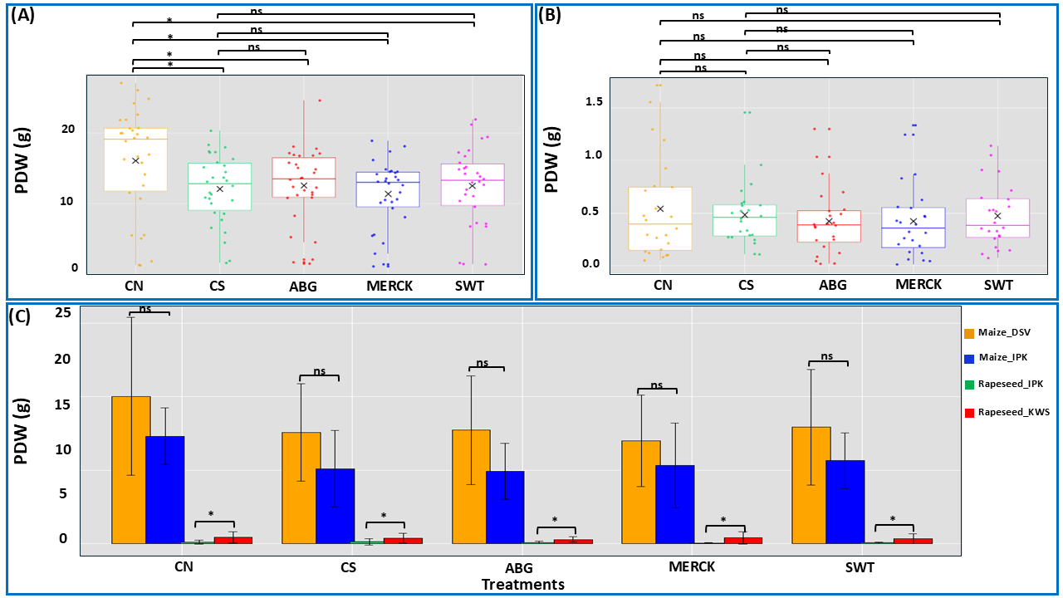
Figure S5. Plant dry weight analysis. Box plots depict PDW in maize (A), rapeseed (B), and cultivar comparisons across both plant species (C). Panels A and B display treatment effects (treatments: SAPs and both control groups) independent of cultivar differences, while panel C illustrates the influence of cultivar on treatment outcomes. Statistical analysis was performed using the Kruskal–Wallis test, followed by Dunn’s test for post hoc pairwise comparisons. The symbol ‘ns’ denotes no significant difference between comparison pairs, and ‘*’ indicates significant differences at α = 0.05. The ‘×’ symbol represents the mean value for each treatment. In panel C, the colors represent the following genotypes: orange color stands for the maize genotype provided by DSV company, blue color stands for the maize genotype from IPK, green color stands for rapeseed genotype provided by IPK, and red color stands for the rapeseed genotype from KWS company.

Plant Fresh Weight (PFW)
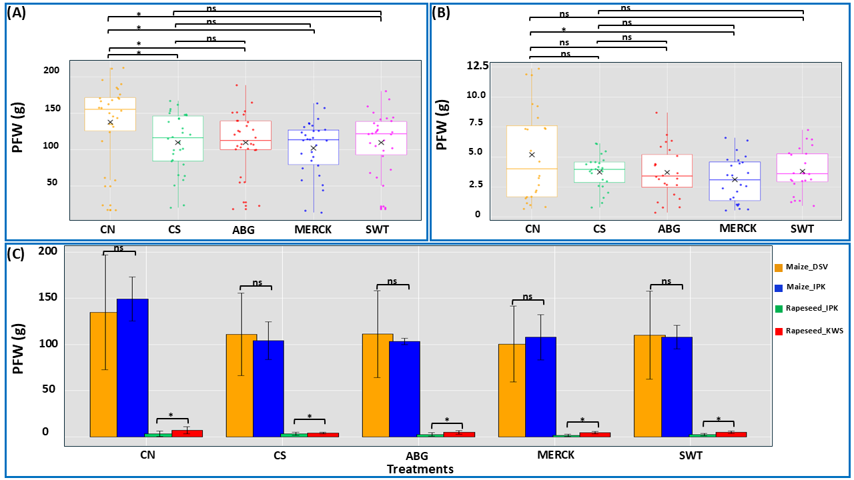
Figure S6. Plant fresh weight analysis. Box plots depicting PFW in maize (A), rapeseed (B), and cultivar comparisons across both plant species (C). Panels A and B depict treatment effects (treatments: SAPs and both control groups) independent of cultivar differences, while panel C illustrates the influence of cultivar on treatment outcomes. Statistical analysis was performed using the Kruskal–Wallis test, followed by Dunn’s test for post hoc pairwise comparisons. The symbol ‘ns’ denotes no significant difference between comparison pairs, and ‘*’ indicates significant differences at α = 0.05. The ‘×’ symbol represents the mean value for each treatment. In panel C, the colors represent the following genotypes: orange color stands for the maize genotype provided by DSV company, blue color stands for the maize genotype from IPK, green color stands for rapeseed genotype provided by IPK, and red color stands for the rapeseed genotype from KWS company.

Root Fresh Weight (RFW)
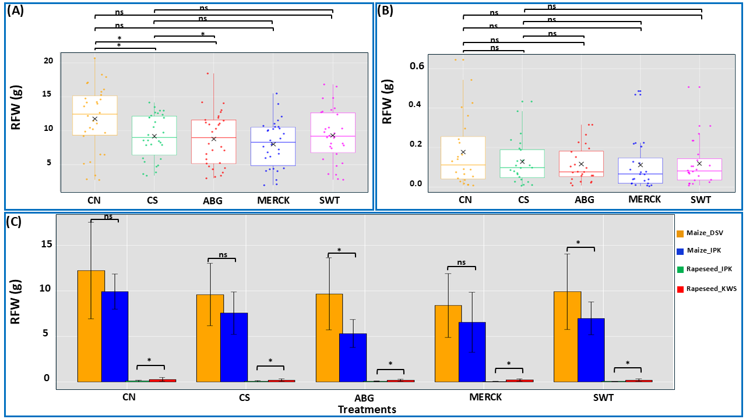
Figure S7. Root fresh weight analysis. Box plots depicting RFW in maize (A), rapeseed (B), and cultivar comparisons across both plant species (C). Panels A and B depict treatment effects (treatments: SAPs and both control groups) independent of cultivar differences, while panel C illustrates the influence of cultivar on treatment outcomes. Statistical analysis was performed using the Kruskal–Wallis test, followed by Dunn’s test for post hoc pairwise comparisons. The symbol ‘ns’ denotes no significant difference between comparison pairs, and ‘*’ indicates significant differences at α = 0.05. The ‘×’ symbol represents the mean value for each treatment. In panel C, the colors represent the following genotypes: orange color stands for the maize genotype provided by DSV company, blue color stands for the maize genotype from IPK, green color stands for rapeseed genotype provided by IPK, and red color stands for the rapeseed genotype from KWS company.

Root Dry Weight (RDW)
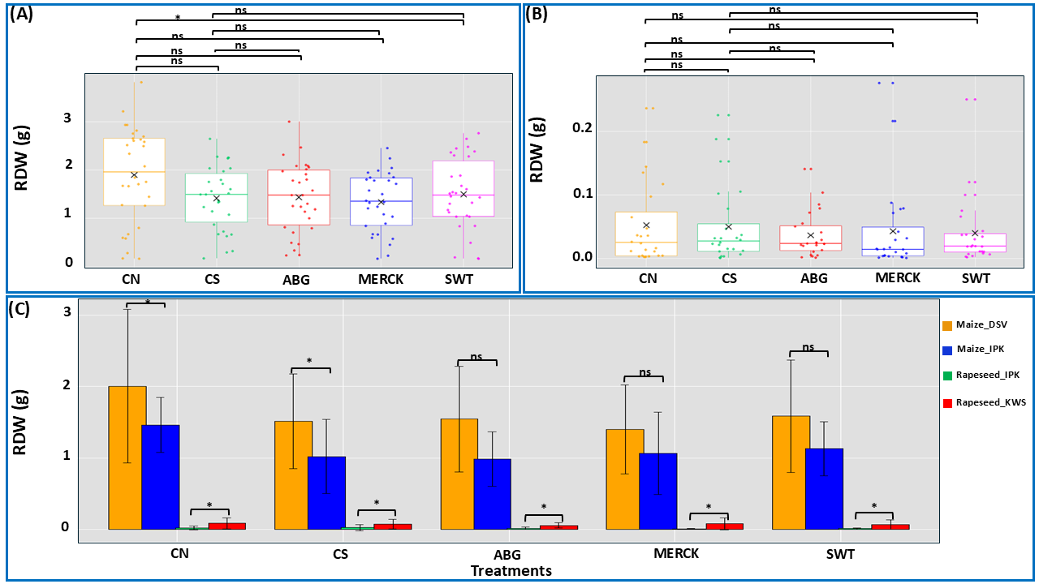
Figure S8. Root dry weight analysis. Box plots depict RDW in maize (A), rapeseed (B), and cultivar comparisons across both plant species (C). Panels A and B display treatment effects (treatments: SAPs and both control groups) independent of cultivar differences, while panel C illustrates the influence of cultivar on treatment outcomes. For maize, statistical analysis was performed using one-way ANOVA, followed by Tukey’s test for post hoc pairwise comparisons. Statistical analysis for rapeseed was conducted using the Kruskal–Wallis test, followed by Dunn’s test for post hoc pairwise comparisons. For the cultivar comparison, one-way ANOVA was performed, with Tukey’s test applied for post hoc pairwise comparisons. The symbol ‘ns’ denotes no significant difference between comparison pairs, and ‘*’ indicates significant differences at α = 0.05. The ‘×’ symbol represents the mean value for each treatment. In panel C, the colors represent the following genotypes: orange color stands for the maize genotype provided by DSV company, blue color stands for the maize genotype from IPK, green color stands for rapeseed genotype provided by IPK, and red color stands for the rapeseed genotype from KWS company.

Shoot Dry Weight (SDW)
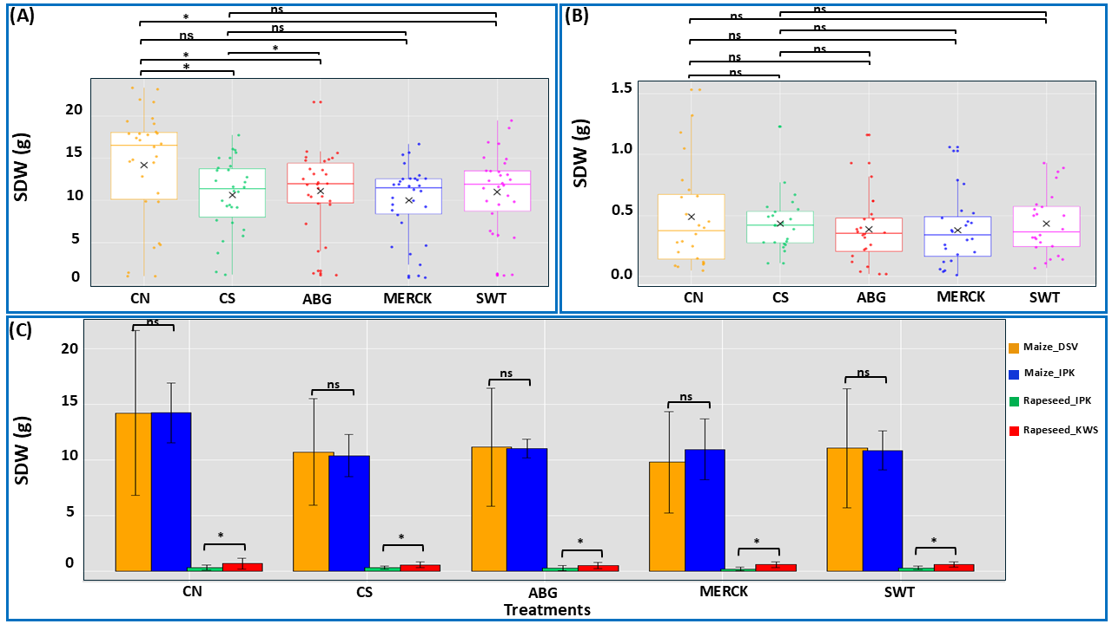
Figure S9. Shoot dry weight analysis. Box plots display SDW in maize (A), rapeseed (B), and cultivar comparisons across both plant species (C). Panels A and B depict treatment effects (treatments: SAPs and both control groups) independent of cultivar differences, while panel C illustrates the influence of cultivar on treatment outcomes. For maize, statistical analysis was performed using one-way ANOVA, followed by Tukey’s test for post hoc pairwise comparisons. Statistical analysis for rapeseed was conducted using the Kruskal–Wallis test, followed by Dunn’s test for post hoc pairwise comparisons. The symbol ‘ns’ denotes no significant difference between comparison pairs, and ‘*’ indicates significant differences at α = 0.05. The ‘×’ symbol represents the mean value for each treatment. In panel C, the colors represent the following genotypes: orange color stands for the maize genotype provided by DSV company, blue color stands for the maize genotype from IPK, green color stands for rapeseed genotype provided by IPK, and red color stands for the rapeseed genotype from KWS company.

Root Water Content (RWC)
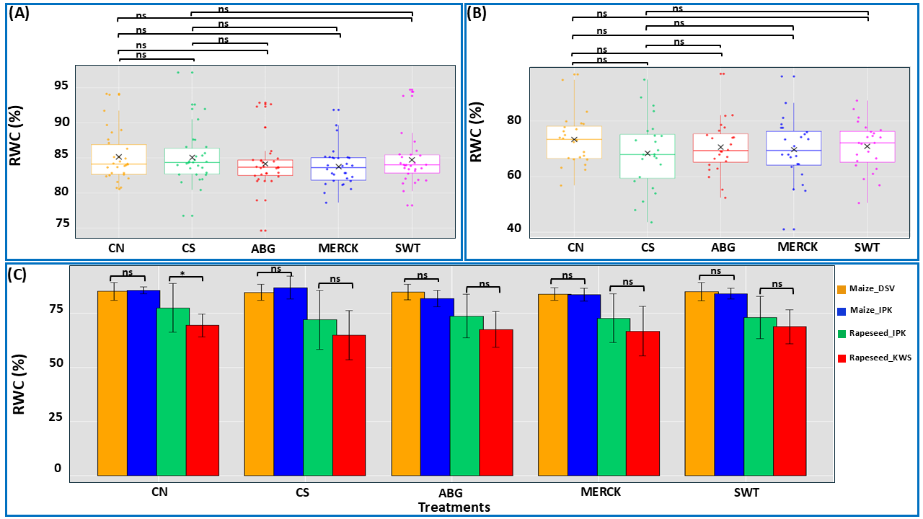
Figure S10. Root water content analysis. Box plots display RWC in maize (A), rapeseed (B), and cultivar comparisons across both plant species (C). Panels A and B depict treatment effects (treatments: SAPs and both control groups) independent of cultivar differences, while panel C illustrates the influence of cultivar on treatment outcomes. For maize, statistical analysis was performed using the Kruskal–Wallis test, followed by Dunn’s test for post hoc pairwise comparisons. Statistical analysis for rapeseed was conducted using one-way ANOVA, followed by Tukey’s test for post hoc pairwise comparisons. The symbol ‘ns’ denotes no significant difference between comparison pairs, and ‘*’ indicates significant differences at α = 0.05. The ‘×’ symbol represents the mean value for each treatment. In panel C, the colors represent the following genotypes: orange color stands for the maize genotype provided by DSV company, blue color stands for the maize genotype from IPK, green color stands for rapeseed genotype provided by IPK, and red color stands for the rapeseed genotype from KWS company.

Shoot Water Content (SWC)
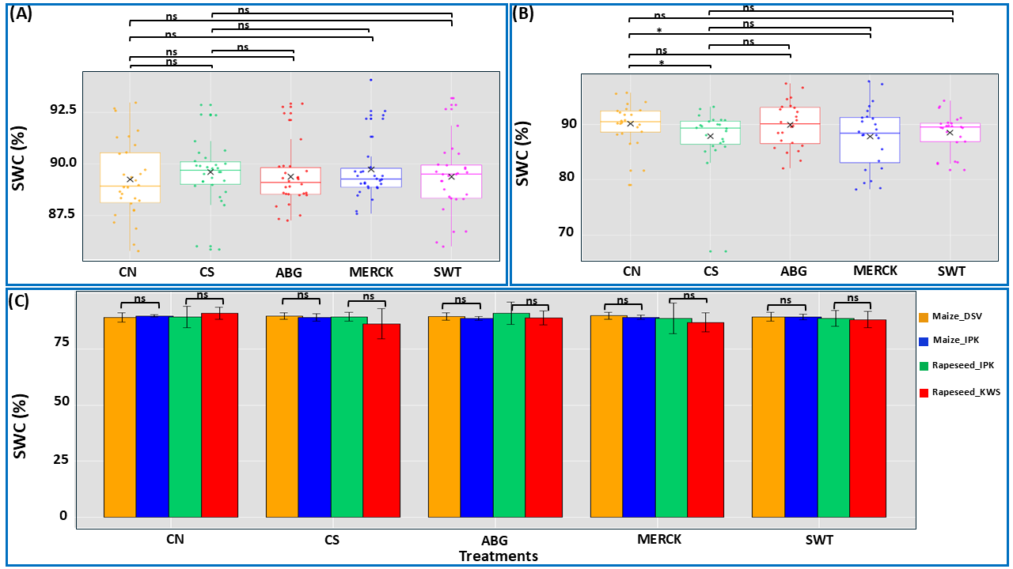
Figure S11. Shoot water content analysis. Box plots depicting SWC in maize (A), rapeseed (B), and cultivar comparisons across both plant species (C). Panels A and B depict treatment effects (treatments: SAPs and both control groups) independent of cultivar differences, while panel C illustrates the influence of cultivar on treatment outcomes. Statistical analysis was performed using the Kruskal–Wallis test, followed by Dunn’s test for post hoc pairwise comparisons. The symbol ‘ns’ denotes no significant difference between comparison pairs, and ‘*’ indicates significant differences at α = 0.05. The ‘×’ symbol represents the mean value for each treatment. In panel C, the colors represent the following genotypes: orange color stands for the maize genotype provided by DSV company, blue color stands for the maize genotype from IPK, green color stands for rapeseed genotype provided by IPK, and red color stands for the rapeseed genotype from KWS company.

